1.

Queue Array Header File:
1 #include <stdio.h>
2 #include <stdlib.h>
3
4 typedef struct queue * ptr;
5 typedef struct queue{
6 int front;
7 int rear;
8 int size;
9 int capacity;
10 int *arr;
11 }queue;
12
13 ptr create(int size){
14 ptr a = malloc(sizeof(queue));
15 a->size = 0;
16 a->capacity = size;
17 a->front = a->rear = -1;
18 a->arr = malloc(sizeof(int)*size);
19 return a;
20 }
21
22 int isEmpty(ptr s){
23 if(s->size == 0){
24 return 1;
25 }
26 else return 0;
27 }
28
29 int isFull(ptr s){
30 if(s->size == s->capacity){
31 return 1;
32 }
33 else return 0;
34 }
35
36 void enqueue(ptr s, int elem){
37 if(isEmpty(s)){
38 s->arr[0]=elem;
39 s->size+=1;
40 s->front = s->rear = 0;
41 }
42 else if(isFull(s)){
43 printf("Error, Queue is Full\n");
44 }
45 else{
46 s->rear = (s->rear+1)%s->capacity;
47 s->arr[s->rear]=elem;
48 s->size+=1;
49 }
50
51 }
52
53 void dequeue(ptr s){
54 if(isEmpty(s)){
55 printf("Error, Queue is Empty\n");
56 }
57 else{
58 s->front = (s->front + 1)%s->capacity;
59 s->size-=1;
60
61 }
62 }
63
64 void display(ptr s){
65 int i;
66 for(i=s->front;i!=s->rear;){
67 printf("%d ",s->arr[i] );
68 i = (i + 1) % s->capacity;
69 }
70 printf("%d\n",s->arr[i]);
71 }
72
73 void dispose(ptr s){
74 free(s->arr);
75 free(s);
76 }
77

Queue Array Application File:

1 #include <stdio.h>
2 #include <stdlib.h>
3 #include "queueadt.h"
4
5 void main(){
6 ptr q = create(5);
7 int choice =1;
8 int tmp;
9 while(choice != 0){
10 printf("1. Enqueue, 2.Dequeue, 3.Display\n");
11 scanf("%d",&choice);
12 switch(choice){
13 case 1:
14 scanf("%d",&tmp);
15 enqueue(q,tmp);
16 break;
17 case 2:
18 dequeue(q);
19 break;
20 case 3:
21 display(q);
22 break;
23 }
24 }
25 }

Input/Output:

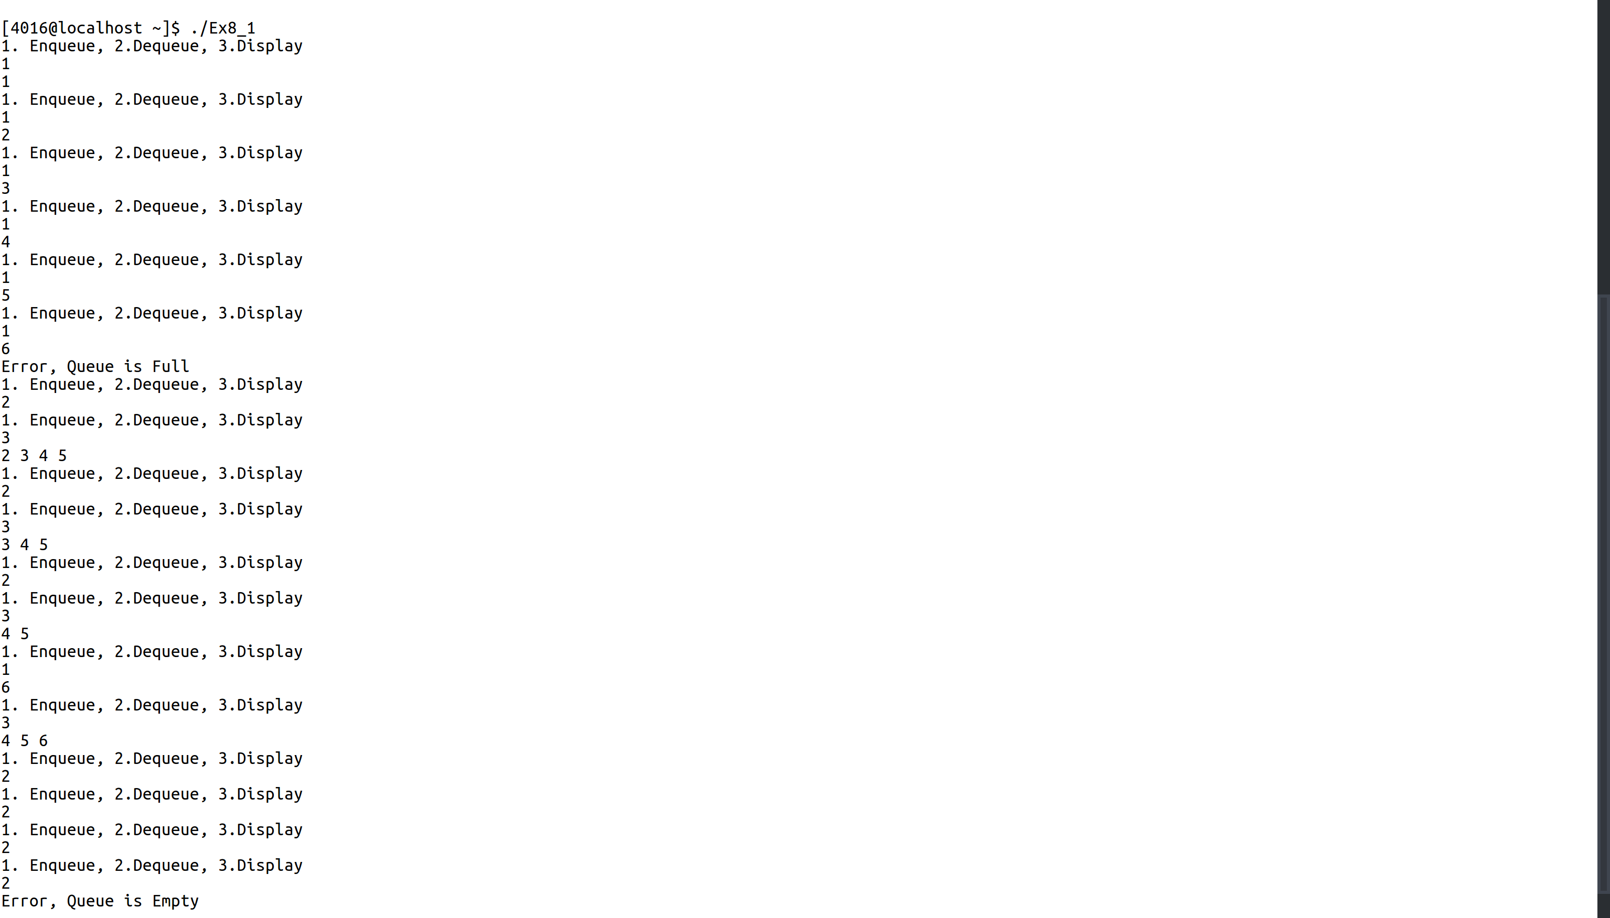

2.

Queue Linked List Header File:
1 #include <stdio.h>
2 #include <stdlib.h>
3 typedef int datatype;
4 typedef struct node* ptr;
5 typedef struct queue* ptrq;
6 typedef struct queue{
7 ptr head;
8 ptr tail;
9 }queue;
10
11 typedef struct node{
12 datatype data;
13 ptr next;
14 }node;
15
16 int isEmpty(ptrq q){
17 return q->head==NULL;
18 }
19 ptrq create(){
20 ptrq a = malloc(sizeof(queue));
21 a->head = a->tail = NULL;
22 return a;
23 }
24
25 void enqueue(ptrq q, datatype dat){
26 ptr a = malloc(sizeof(node));
27 a->data = dat;
28 a->next = NULL;
29 if(isEmpty(q)){
30 q->head = q->tail = a;
31 }
32 else{
33 q->tail->next = a;
34 q->tail = q->tail->next;
35 }
36 }
37
38 void dequeue(ptrq q){
39 if(isEmpty(q)){
40 printf("Error: Queue is Empty\n");
41 }
42 else if(q->head == q->tail){
43 q->head = q->tail = NULL;
44 }
45 else{
46 ptr tmp = q->head;
47 q->head = q->head->next;
48 free(tmp);
49 }
50 }
51
52 void display(ptrq q){
53 ptr tmp = q->head;
54 while(tmp != NULL){
55 printf("%d ",tmp->data);
56 tmp = tmp->next;
57
58 }
59 printf("\n");
60
61 }
62

Stack Linked List Application File:

1 #include <stdio.h>
2 #include <stdlib.h>
3 #include "linkedstackadt.h"
4
5 void main(){
6 ptrq q = create();
7 int choice = 1;
8 int qry;
while(choice != 0){
9 printf("1. Enqueue 2. Dequeue 3. Display\n");
10 scanf("%d",&choice);
11 switch(choice){
12 case 1:
13 scanf("%d",&qry);
14 enqueue(q,qry);
15 break;
16 case 2:
17 dequeue(q);
18 break;
19 case 3:
20 display(q);
21 break;
22 }
23 }
24}

Input/Output:
